

mPoint – Description
1 Introduction 4
2 Background 5
3 mPoint Modules 7
3.1 Basic Payment Module 7
3.2 Premium SMS 8
3.3 Mobile Shop 8
3.4 Address Lookup 8
3.5 Mobile Account 8
3.6 Redemption Module 8
3.7 SurePay 9

Terms & Definitions
Throughout the document, terms in bold are products and concepts such as “SMS Receipt” are quoted.
Additionally, the list below explains the different terms, which are used in several sections of this document:
SMS – Short Message Service
MO – Mobile Originated, a message, which has been sent FROM a mobile phone.
MT – Mobile Terminated, a message, which is being sent TO a mobile phone.
PMT – Premium MT, a message, which the end-user incurs a charge for receiving.
MSISDN - Mobile Subscriber ISDN Number, the End-User’s mobile number.
MCC – Mobile Country Code
IDC – International Dialling Code, the first 1 to 3 digits in a MSISDN, which indicates, which country the end-user is in.
Channel – The short code all messages are routed through.
Operator – The mobile network on, which the end-user is a subscriber.
MNC – Mobile Network Code for the Operator
Client – An external service / application that uses mPoint to process payments on the mobile phone.
Keyword – The first word in the MO message, which mPoint uses to determine the price for transactions instantiated via SMS.
End-user – A wireless subscriber from an operator who uses mPoint and thereby becomes a customer.

Introduction
This document will describe the API for Cellpoint Mobile’s cross payment solution: mPoint. mPoint acts as an intermediary between the client and an arbitrary number of clearance houses providing one united API for all payment transactions. Currently the following credit cards / payment systems are supported:
- American Express  - Dankort  - Diners Club | - EuroCard  - JCB  - Maestro | - MasterCard  - Visa  - Visa Electron
mPoint offers a secure method for communicating with both the client and the clearance houses using through HTTPS. This ensures that all end-user data is always encrypted using the newest Internet technology. The following diagram illustrates mPoint’s place in the infrastructure for credit card payments.
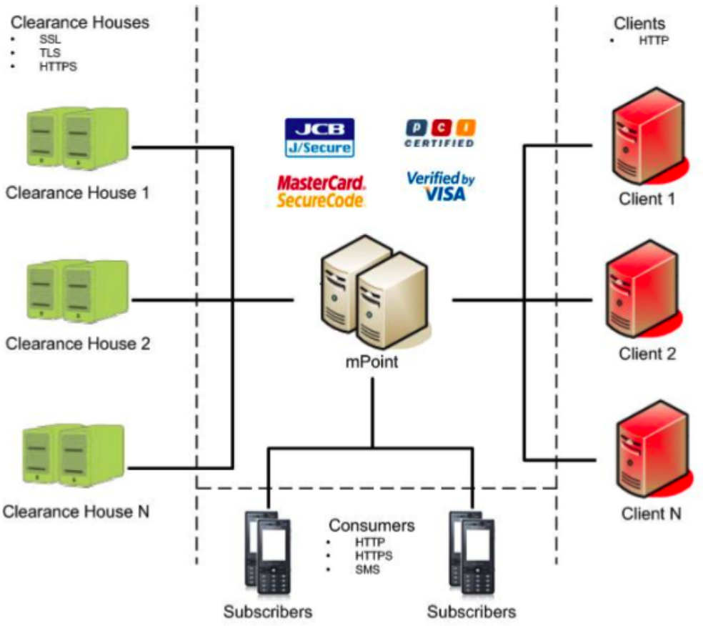
mPoint’s place in the “world” of credit card payment
In addition to aggregating the different interfaces for communicating with a range of clearance houses, mPoint implements the Business Logic necessary to ensure that consumers are never “lost” while making a payment on the mobile phone. Through mPoint’s SurePayTM technology consumers are guided through the payment process and customer service is automatically notified if the customer needs assistance in completing the payment.

Background
mPoint has been designed to process credit card payments in a variety of scenarios including:
- Instant purchase via SMS in response to Billboard / TV / Radio advertisement
- Phone sale through Call Centres
- Purchases of Mobile Applications
- M-Commerce from Mobile Internet Sites
Additionally mPoint can be combined with purchase recommendations upon completion of the payment thereby creating new up selling opportunities for the client. All interaction between the customer and mPoint takes place on the customer’s mobile phone. This allows clients to reach consumers anytime, anywhere!
The diagram below illustrates the payment process in each of the listed scenarios.
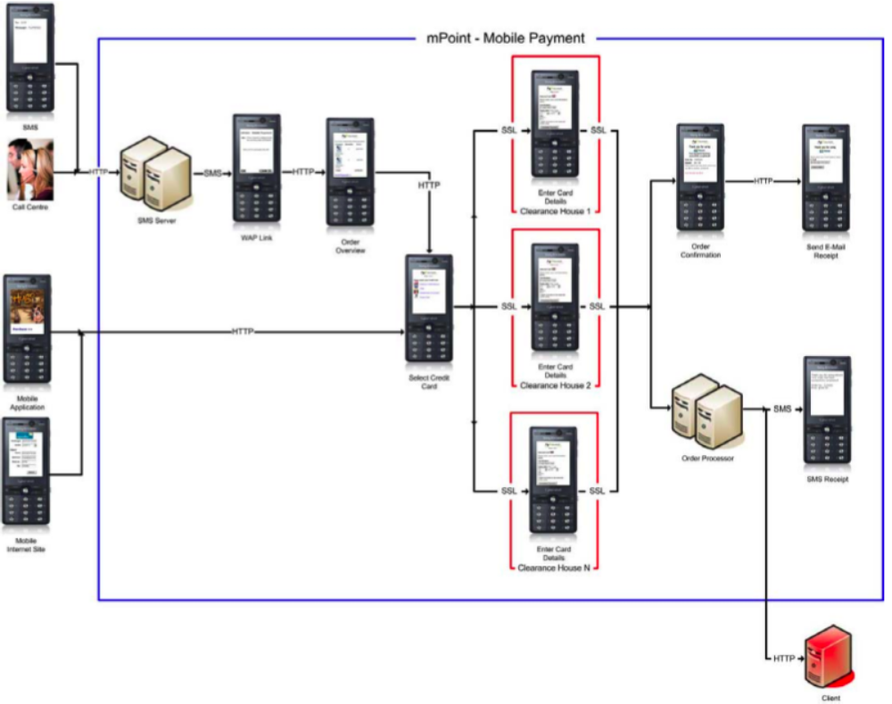
mPoint payment process
The payment process illustrated by the diagram above can be broken into the following steps:
- The Customer sends an MO-SMS in response to the advertisement
- mPoint sends an MT-SMS with a WAP link for processing the payment
- The customer actives the link in order to access the order overview page
- The customer selects “Go to Payment” if the overview is acceptable
- The customer selects his Credit Card
- mPoint routes the payment information to the clearance house
- The customer enters his credit card details
- The clearance house returns the customer to mPoint:
  - mPoint presents the customer with an order confirmation page
  - mPoint receives the payment status from the clearance house and completes the order processing:
    - mPoint sends an “SMS Receipt” to the customer with the order details
    - mPoint sends the payment status to the client’s back office
- From the order confirmation page the customer can optionally:
  - Access another mPoint page where he can enter his e-mail address to receive a receipt via e-mail
  - Access a Mobile Internet Site created by the client, which presents additional purchase recommendations to create up selling opportunities.
Please note, step 1 is only applicable for purchases initiated via SMS and steps 2 to 4 are only applicable in scenarios where the customer is making the purchase via SMS or through Phone Sale. Also all communication with the customer is automatically encrypted by the Mobile Operator Networks using their respective proprietary encryption algorithms. Additionally all communication with the clearance house that processes the customer’s credit card details are encrypted using standard SSL technology. This approach ensures that mPoint is at least as secure as any existing E-Commerce site such as Amazon.
In order to use mPoint, the client must have an agreement in place with one or more clearance houses as mPoint uses their existing infrastructure for processing and clearing the customer’s credit card.
Cellpoint Mobile recommends using DIBS – Payment Services for all mPoint initiatives in Europe. DIBS have proven themselves as a reliable partner with a sophisticated platform, which includes advanced security modules to detect and prevent credit card fraud.

mPoint Modules
mPoint consists of several modules each handling and aspect of mobile payment.
- Basic Mobile Payment
- Premium SMS
- Mobile Shop
- Address Lookup
- Mobile Account
- Redemption Module
- SurePay
Together the modules listed above offer a complete intelligent mobile shop solution with advanced surveillance of all payment transactions.
The remainder of this document will provide a brief overview of each of these modules.

Basic Payment Module
The basic payment module is very similar to what is offered by Payment Service Providers for web based payment transactions. It allows a merchant to offer end-users to pay with credit card directly on the mobile phone. Credit Cards are cleared through Payment Service Providers providing a fully PCI certified solution for accepting payments on the mobile phone.
The following screenshots illustrates the general flow for mPoint’s basic payment module:
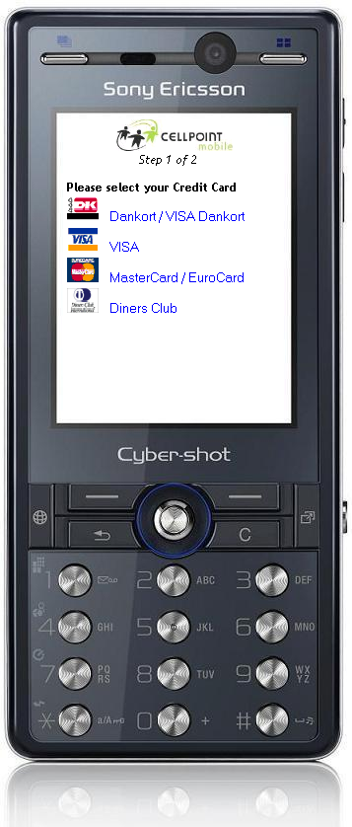  Select Credit Card | → | 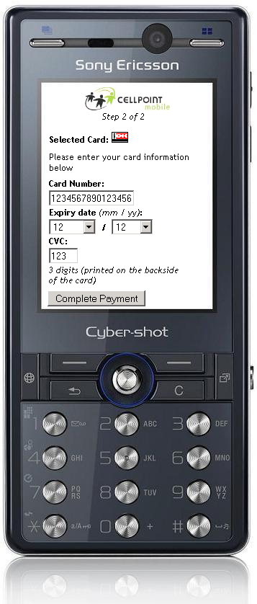  Enter Card Info | → | 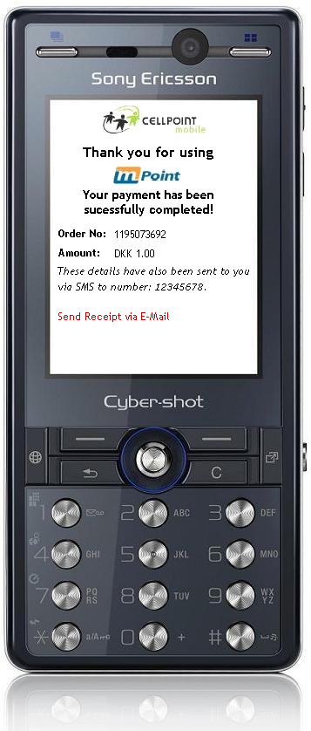  Payment Completed

Premium SMS
As an alternative to, or as a compliment to, credit card based mobile payments, mPoint features charging through premium SMS which allows a merchant to bill consumers directly through the mobile network operator’s billing systems. Premium SMS offers a very simple and convenient approach to accepting micro payments. Payment via premium SMS is made available in the Payment Module just as if it was a credit card.

Mobile Shop
In addition to handling the actual payment transaction, mPoint also offers a complete shopping module optimized for the end-user’s specific mobile device. Through the shopping module a merchant may make a number of products available which can then be browsed and purchased by consumers directly on the mobile phone. Mobile shops may be configured to handle either physical or electronic goods.

Address Lookup
To simplify the process of purchasing physical goods which needs to be delivered, mPoint offers an address lookup module allowing the end-user to simply enter the phone number of the recipient to determine the delivery address. mPoint will automatically make a lookup on the end-user’s own mobile number thereby providing an intelligent default delivery address.

Mobile Account
To further simplify the payment experience, end-users may elect to create a mobile account as part of the payment process thereby storing their credit card information with mPoint. Once stored, mPoint will associate the end-user’s mobile number with the credit card thereby allowing future payments to be completed simply be entering the password selected during account creation. Storing and associating a credit card with a mobile number provides a very powerful and simple approach for returning end-users to complete a payment. Once the credit card information has been stored with mPoint, payments can be made simply by sending an SMS or selecting a product in a mobile shop thereby creating a 1-click purchase experience.

Redemption Module
On top of the previously described payment methods, mPoint also features a complete redemption module enabling end-users to earn loyalty points and receive promotion codes. Through the redemption module, products may be purchased either using previously earned loyalty points or by redeeming a promotion code. The redemption module allows merchants to reward loyal end-users or offer discounts on specific products to featured end-users as part of a marketing initiative.

SurePay
SurePay is an advanced surveillance module which will automatically monitor each initiated payment transaction to ensure that all end-users will successfully complete their payment on the mobile phone. Additionally SurePay will automatically notify the merchant’s customer service agent via email if an end-user appears to be unable complete the payment on his own. SurePay will provide the service agent with all end-user and transaction details allowing customer service to take a proactive approach to solving end-user issues thereby greatly improving the overall user experience. Finally SurePay enables support for phones that does not support standard WAP Push such as the Apple iPhone, the HTC Diamond Touch and the T-Mobile SideKick.

